**GRAPHS-Requirements**

**Graphs are created under Analysis Icon**

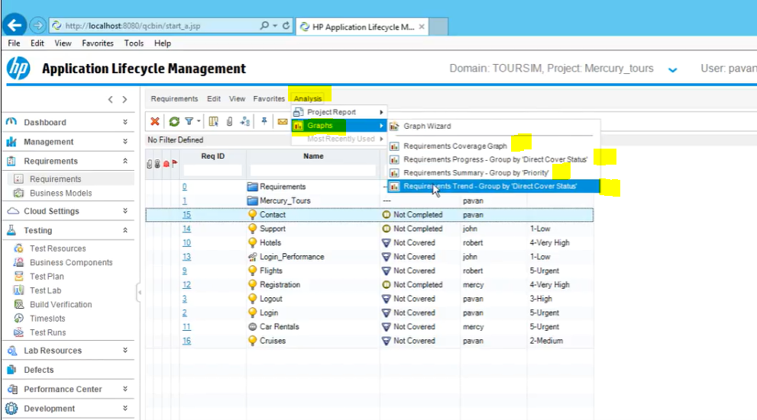

**Requirement Coverage Graph is based on Direct Cover Status**

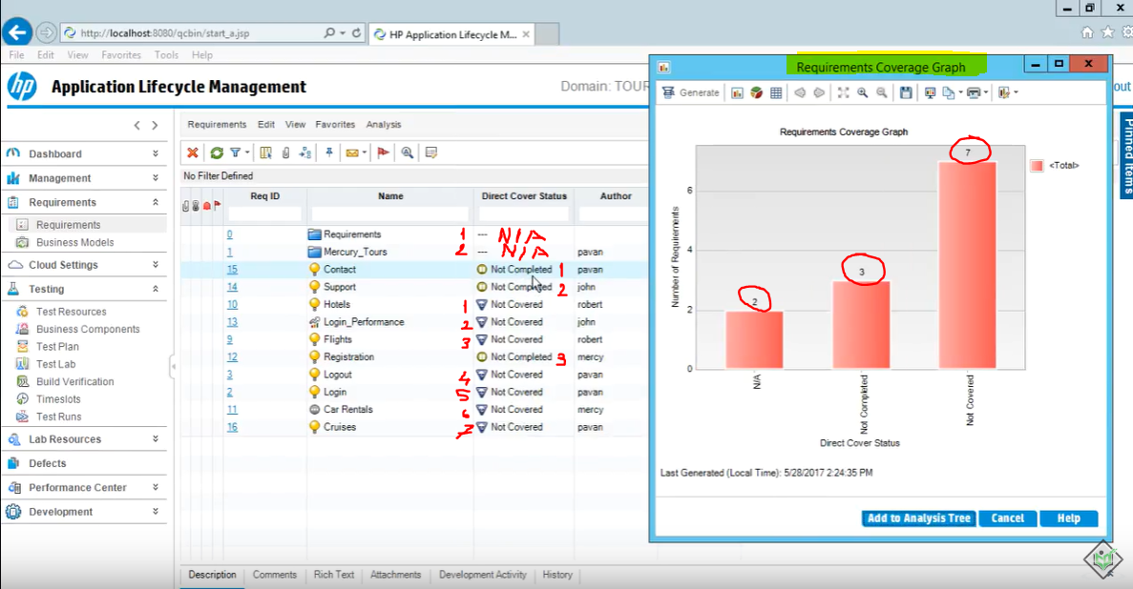

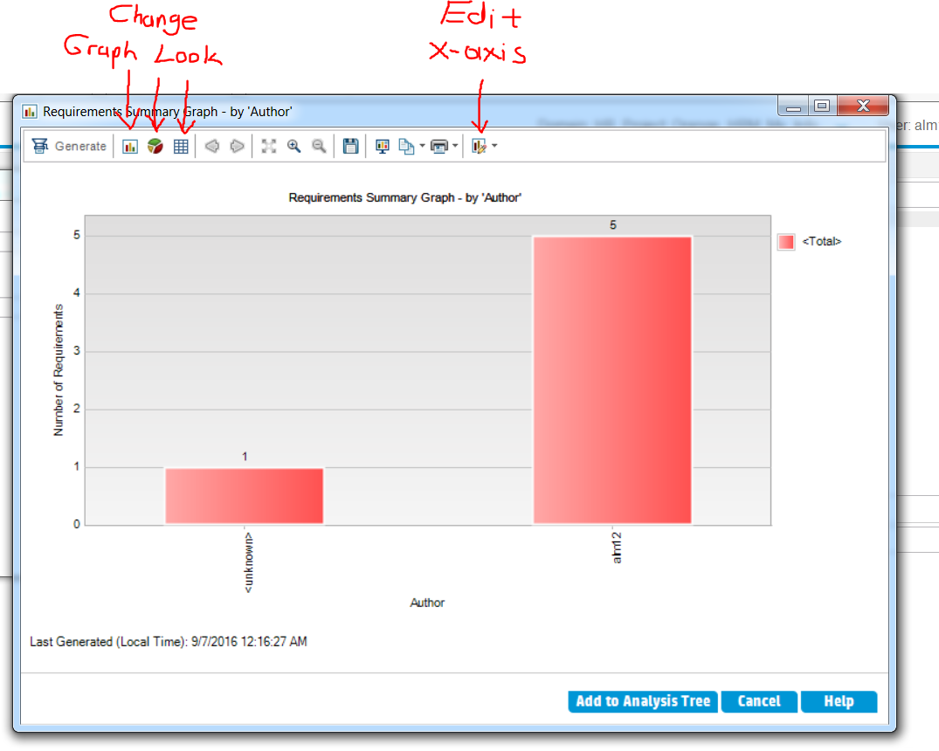

**If you would like to know which are those 3 requirements**

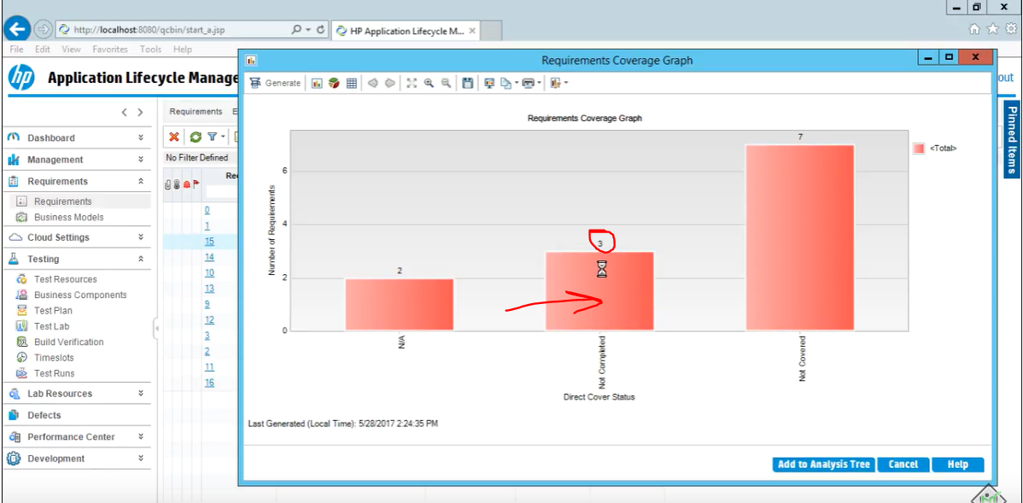

**Double Click on the bar**

**Then From top left**

* **You can export the graph**
* **You can add or remove columns, change column locations**
* **You can see requirement details**

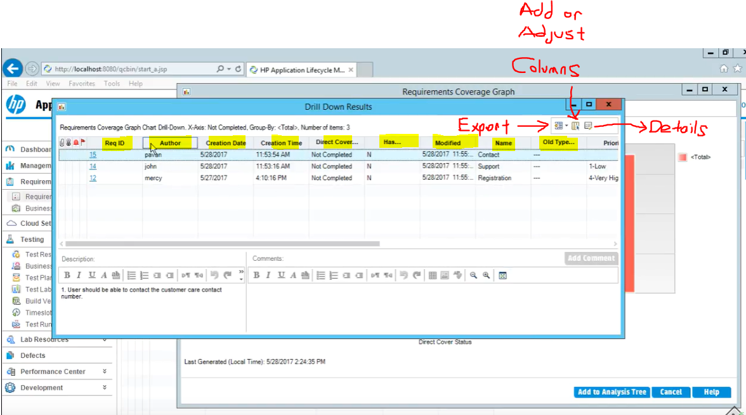

**Requirement Progress – Group by Direct cover Status**

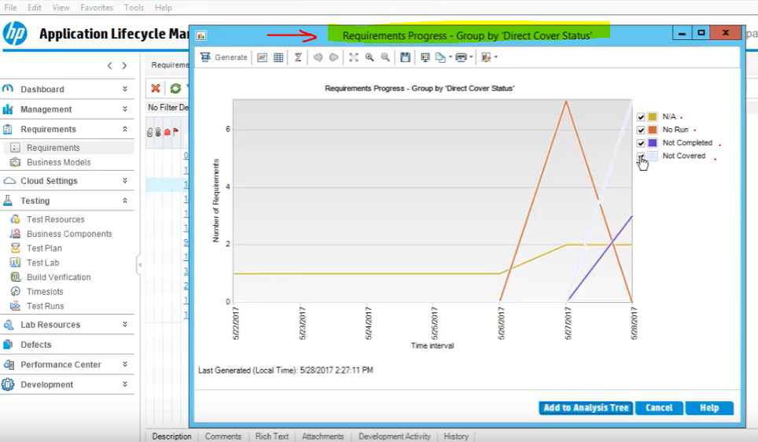

**Requirement Summary – Group by Priority**

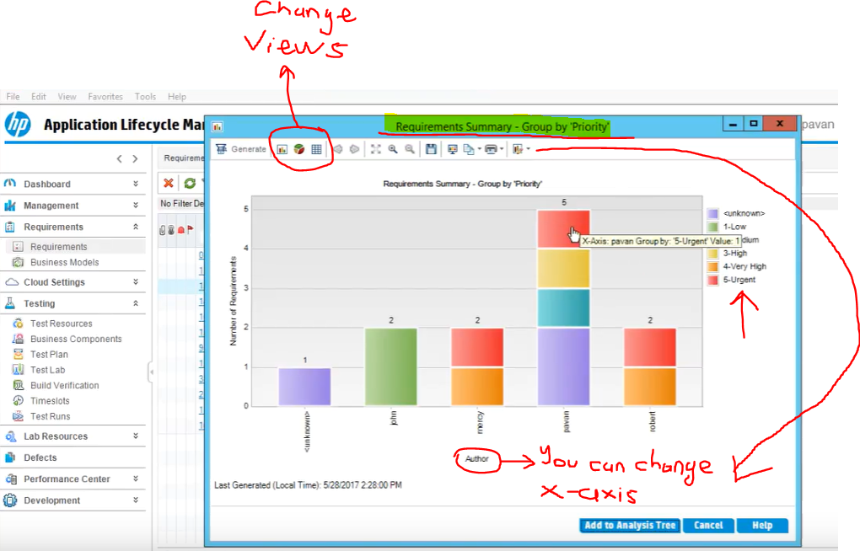

**Requirement Trend – Group by Direct cover Status**

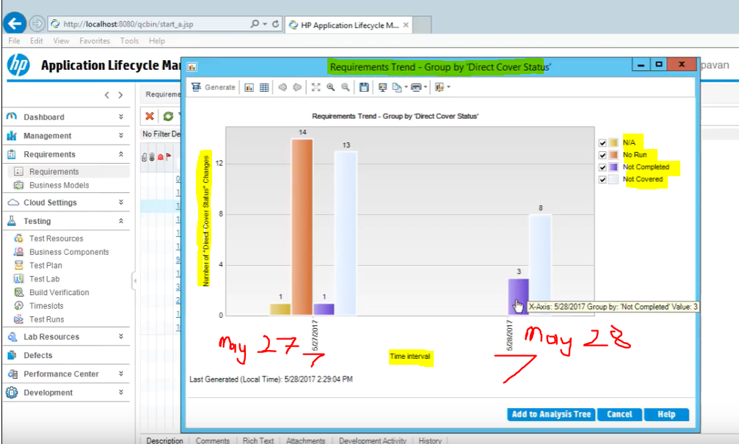

**Customizing Graphs can be done from “Set Graph Appearance” icon**

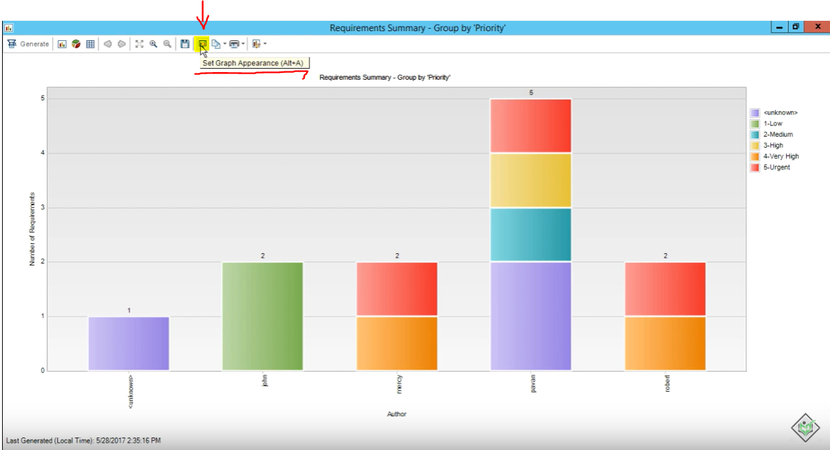

**Click on the icon and You can change the titles;**

* **Graph title and Fonts**
* **Y-axis title (just the name)**
* **Y-axis title**

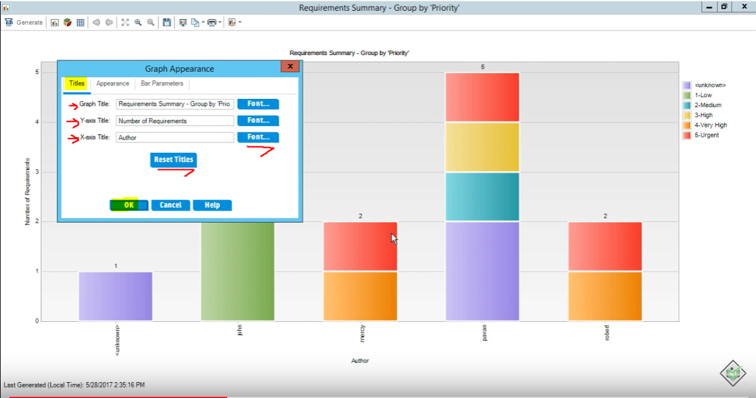

**Click on “appearance”**

**You can adjust the actual appearance here**

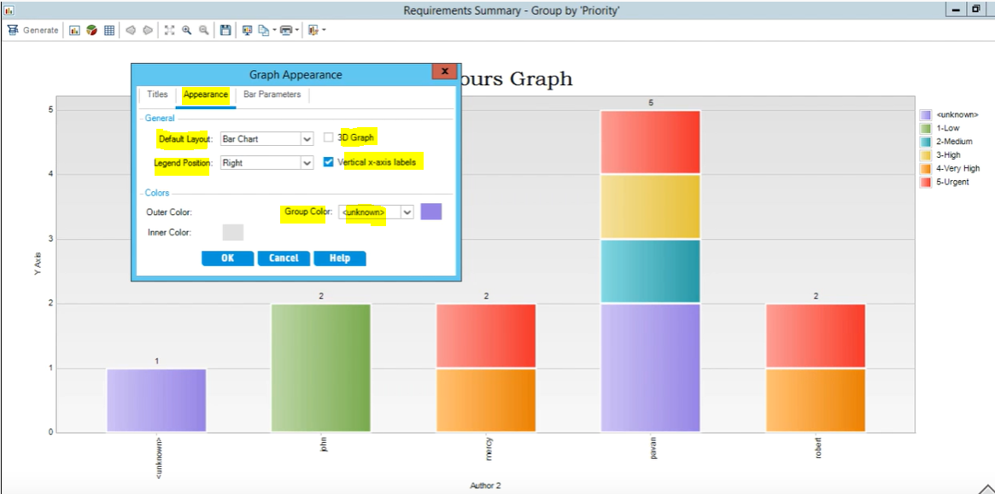

**Click on “appearance”**

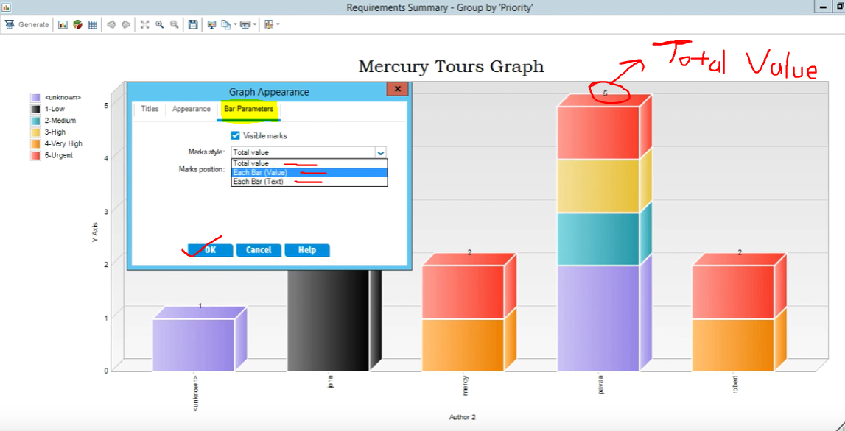

**IF YOU WANT TO CREATE A CUSTOM GRAPH YOU CAN USE “GRAPH WIZARD”**

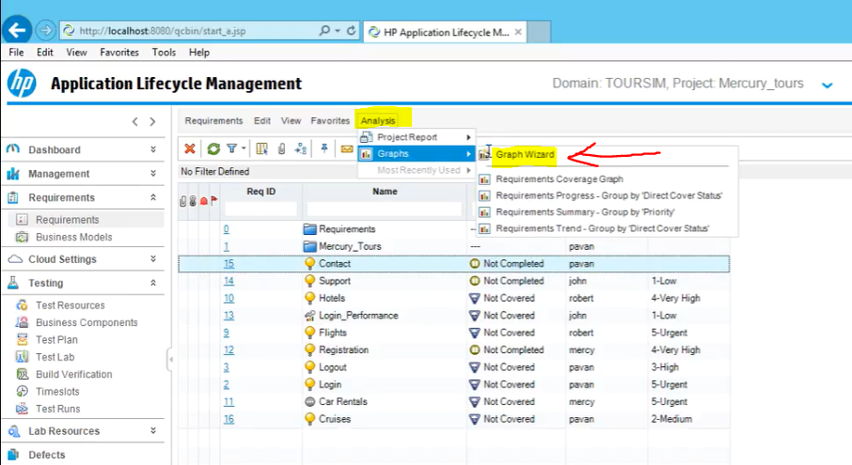

**Customize by reading the description and answering questions**